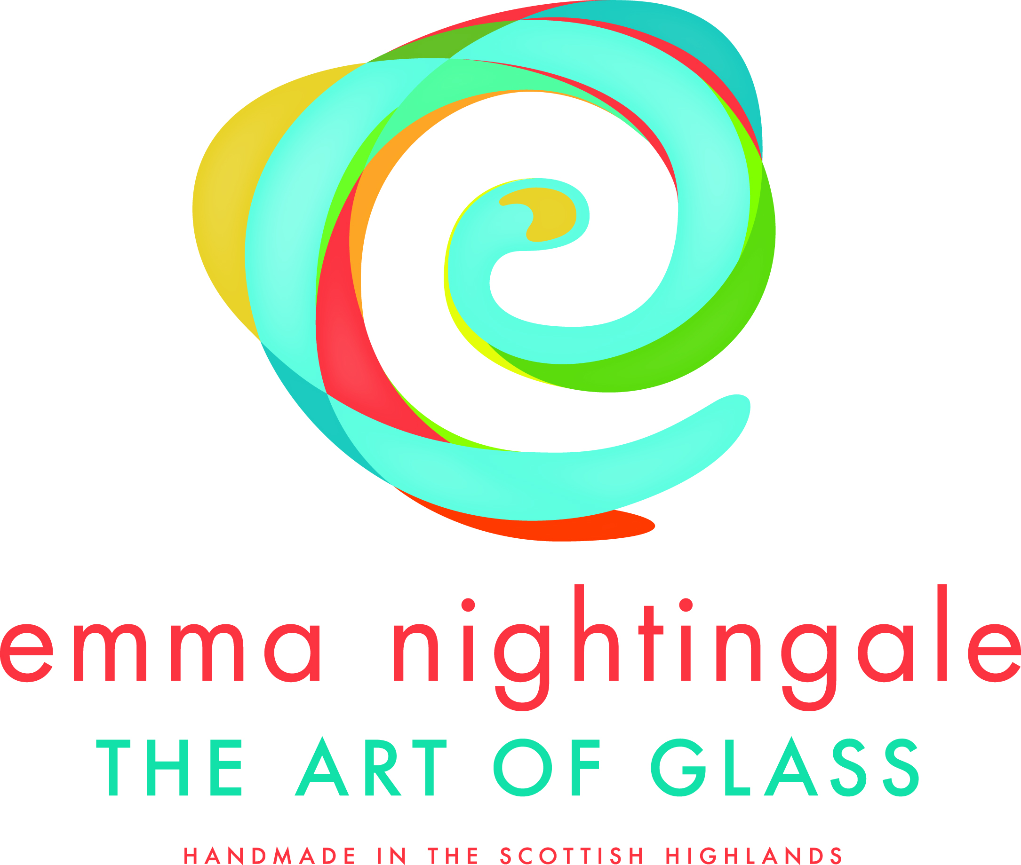

POP UP IN WORMSHILL VILLAGE HALL

ON

THURSDAY 4 JULY FROM 4-8PM

Straight from Handmade Oxford, the International Arts Festival at Waterperry Gardens, Emma will provide a display of her kiln formed glass – coasters, bowls, small, medium and large and wall art.

Come along and take a look – no obligation to buy ……if you want to it can be arranged.

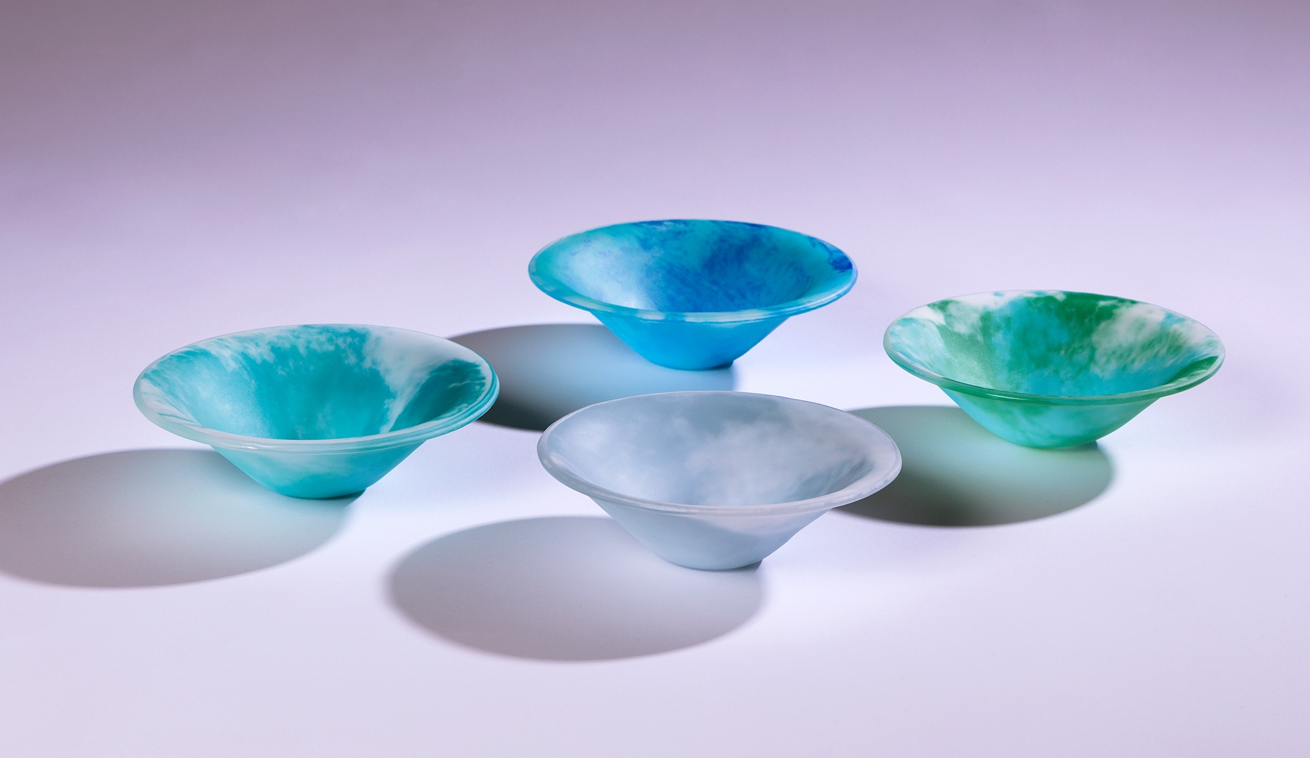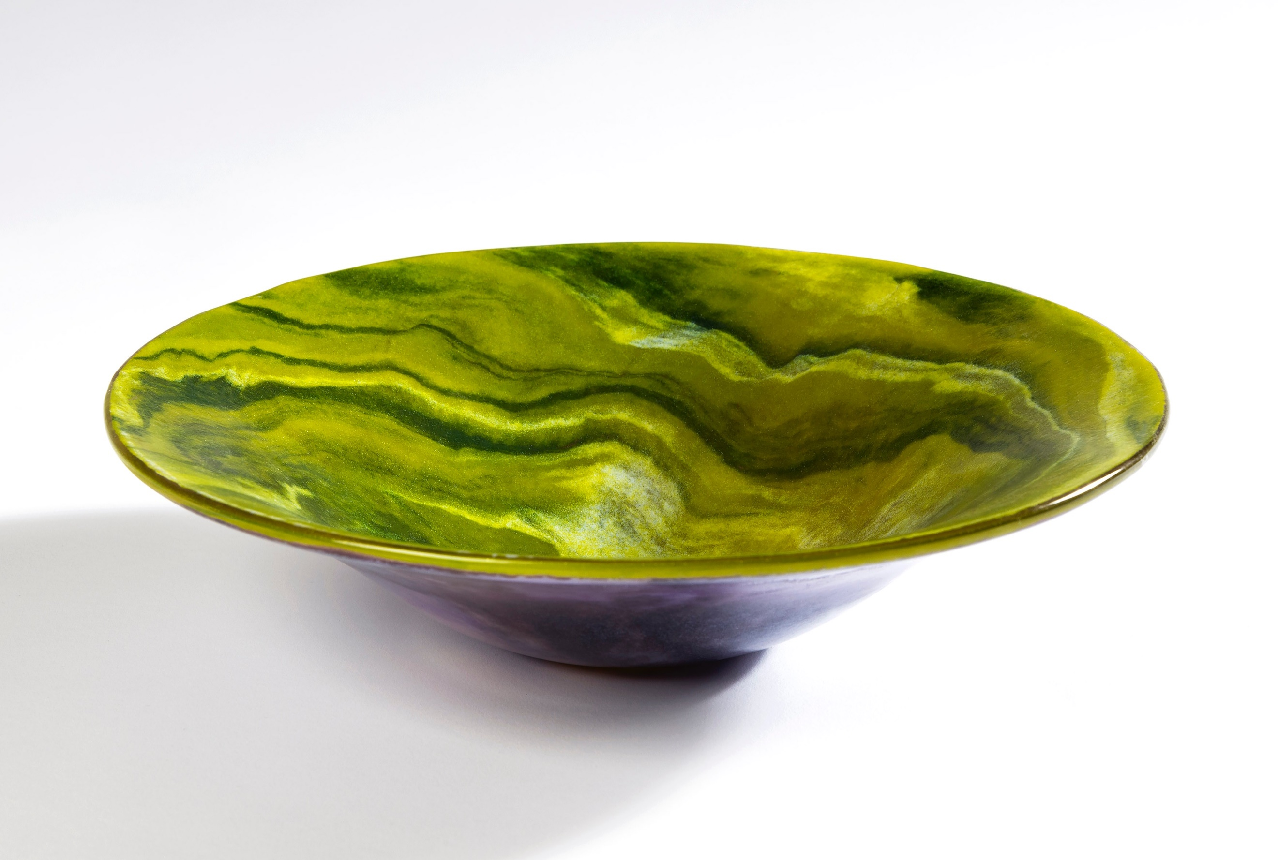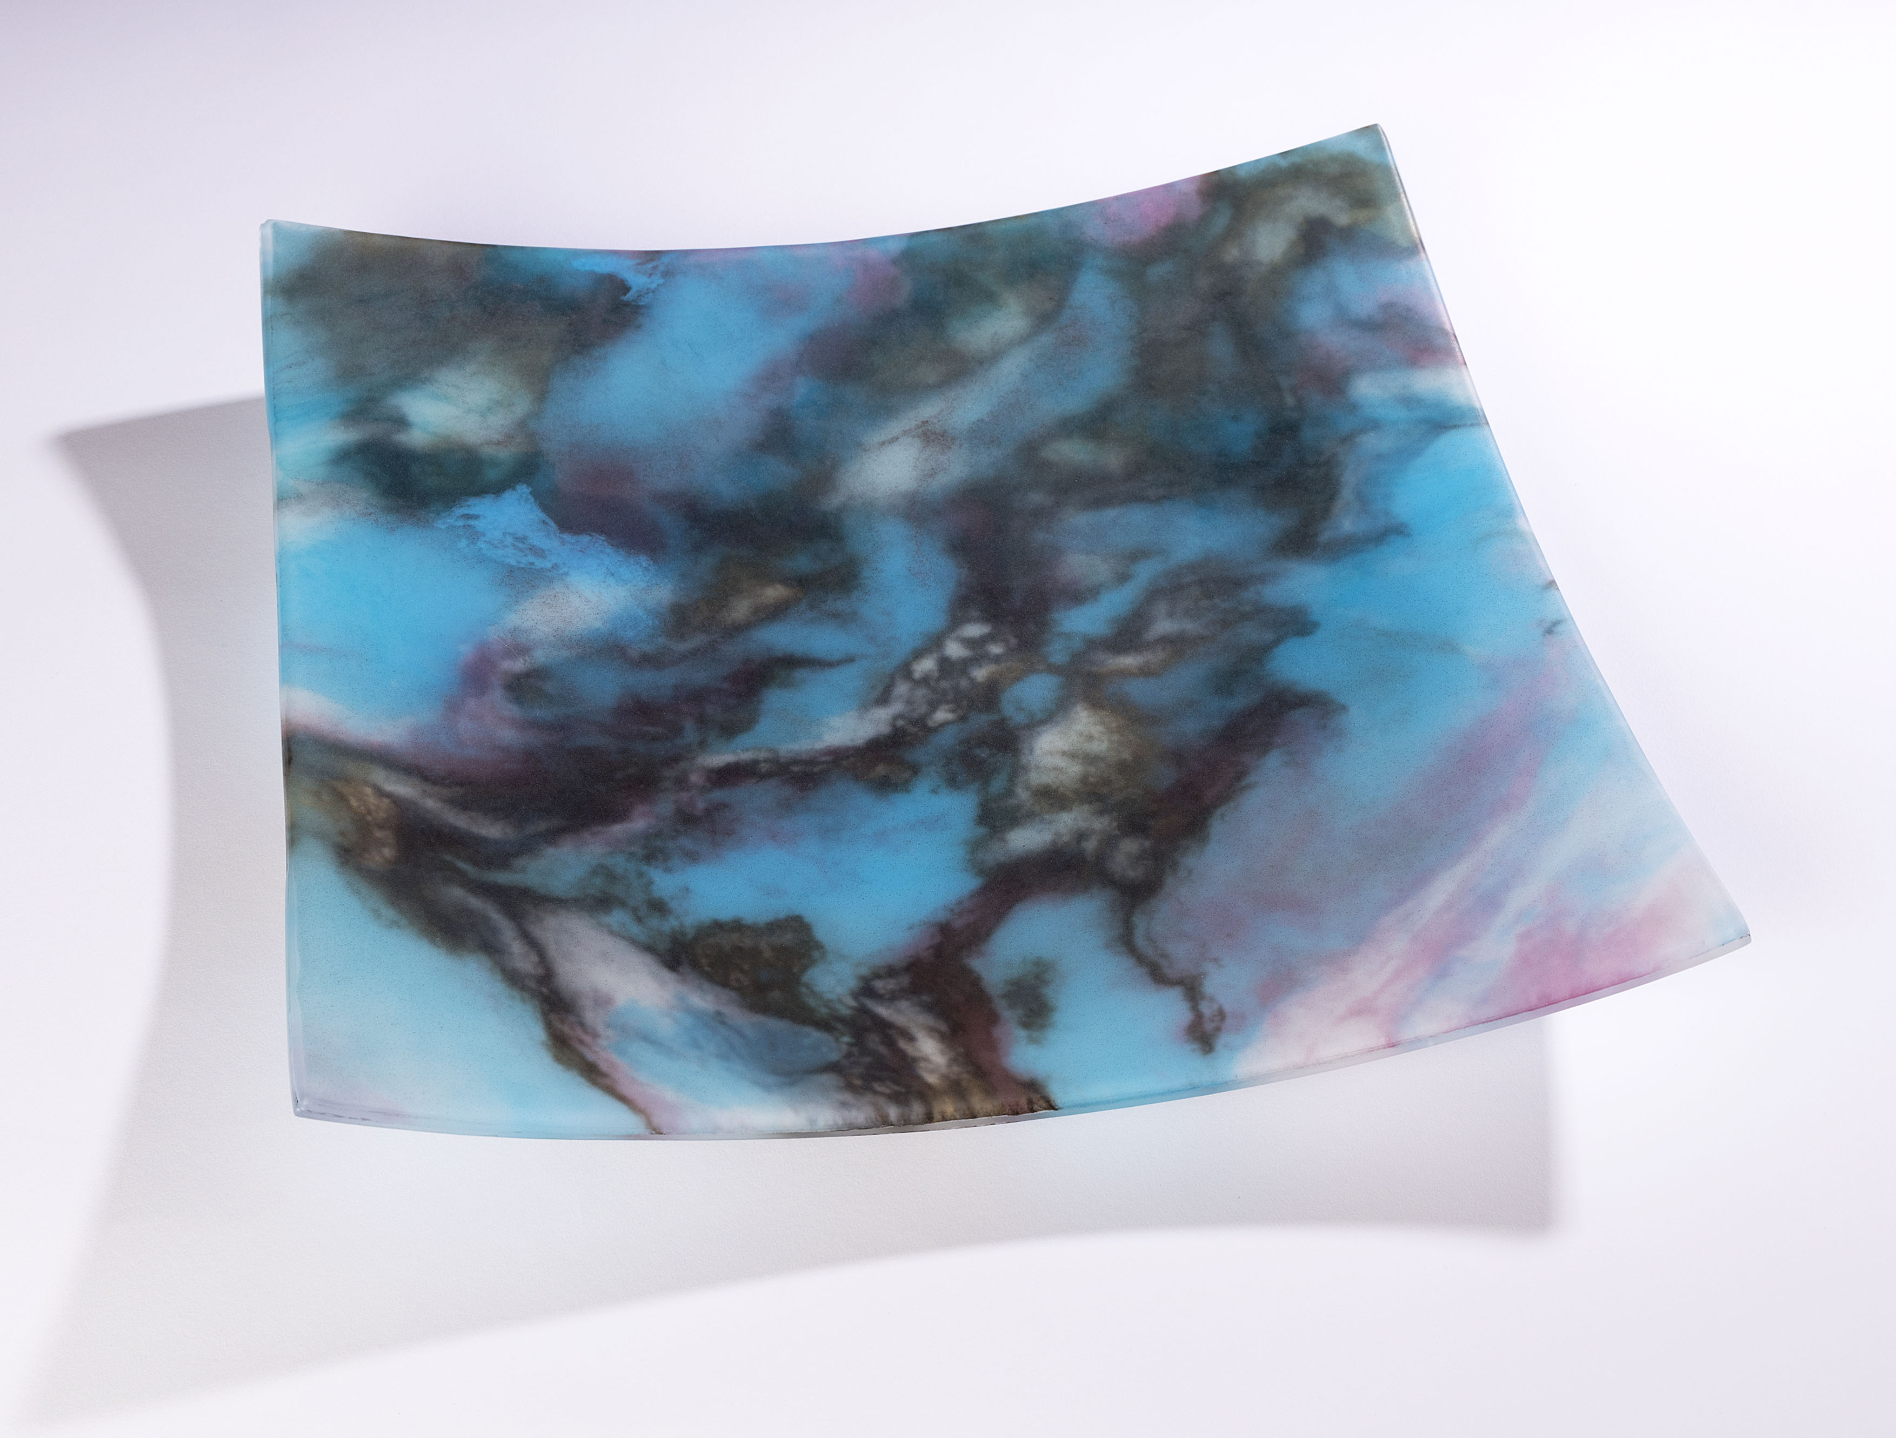
For further details call Emma on 07771 595391 or email her at emma@emmanightingaleglass.co.uk

